Understanding Correlations . . .
EDP560

The following correlations come from an undergraduate class of students.

- True or False: Students who performed better in the course also had higher self-efficacy?

- True or False: One could posit from this data that a mastery orientation contributes approximately 25 % of the variance in explaining self-efficacy for self-regulated learning.

- True or False: Students who believe in fixed ability also tend to believe in quick learning?

- True or False: Having high self-efficacy for teaching was predictive of high scores on the final exam?

- True or False: Education majors in this sample tend to have a greater mastery orientation and self-efficacy for self-regulated learning that non-education majors.

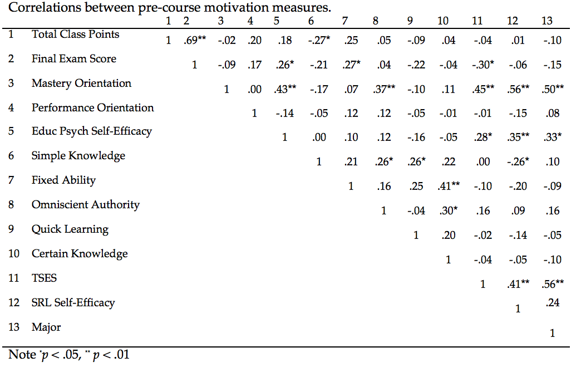

Notes: Major was coded as 1 for non-education majors and 2 for education majors. TSES = self-efficacy for teaching. SRL Self-Efficacy is self-efficacy for self-regulated learning. Educ Psych Self-Efficacy is self-efficacy for performance within educational psychology.

